# **Attention Mechanism | Seq2Seq Networks | Encoder Decoder Architecture**

1. **Background: The Need for Attention**
   * The **Attention Mechanism** is necessary because the standard **Encoder-Decoder Architecture** has problems.
   * The standard architecture processes an entire input sentence step-by-step using an **Encoder** (e.g., based on LSTM cells).
   * After processing the entire sentence, the Encoder generates a single **summary vector** (or representation), which is a set of numbers representing the input sentence.
   * This summary vector is then passed to the **Decoder** (also potentially using LSTMs), which generates the output sentence step-by-step using this single vector as input at each step.

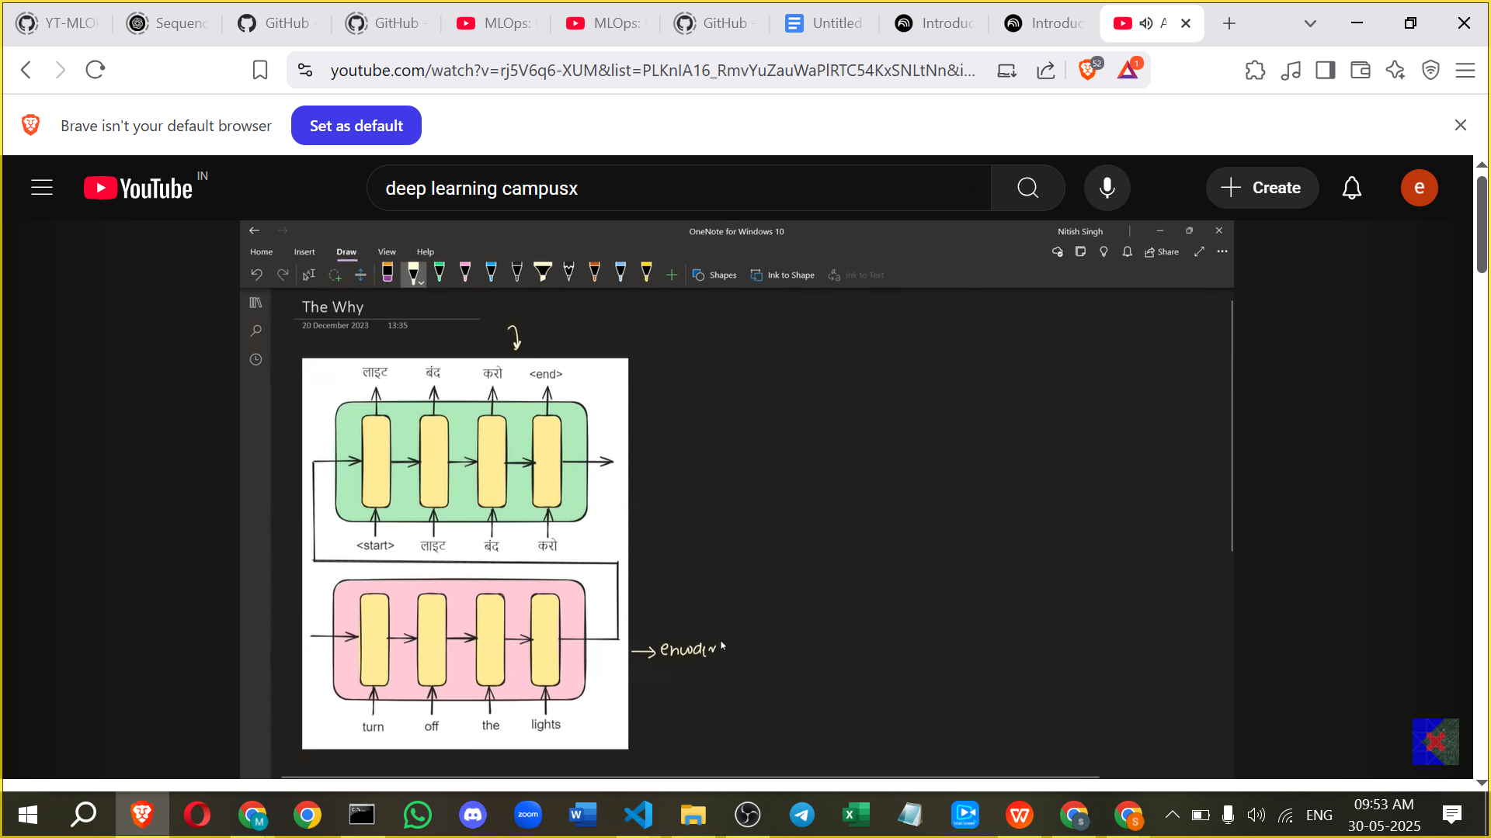

1. **Problems with the Standard Encoder-Decoder Architecture  
   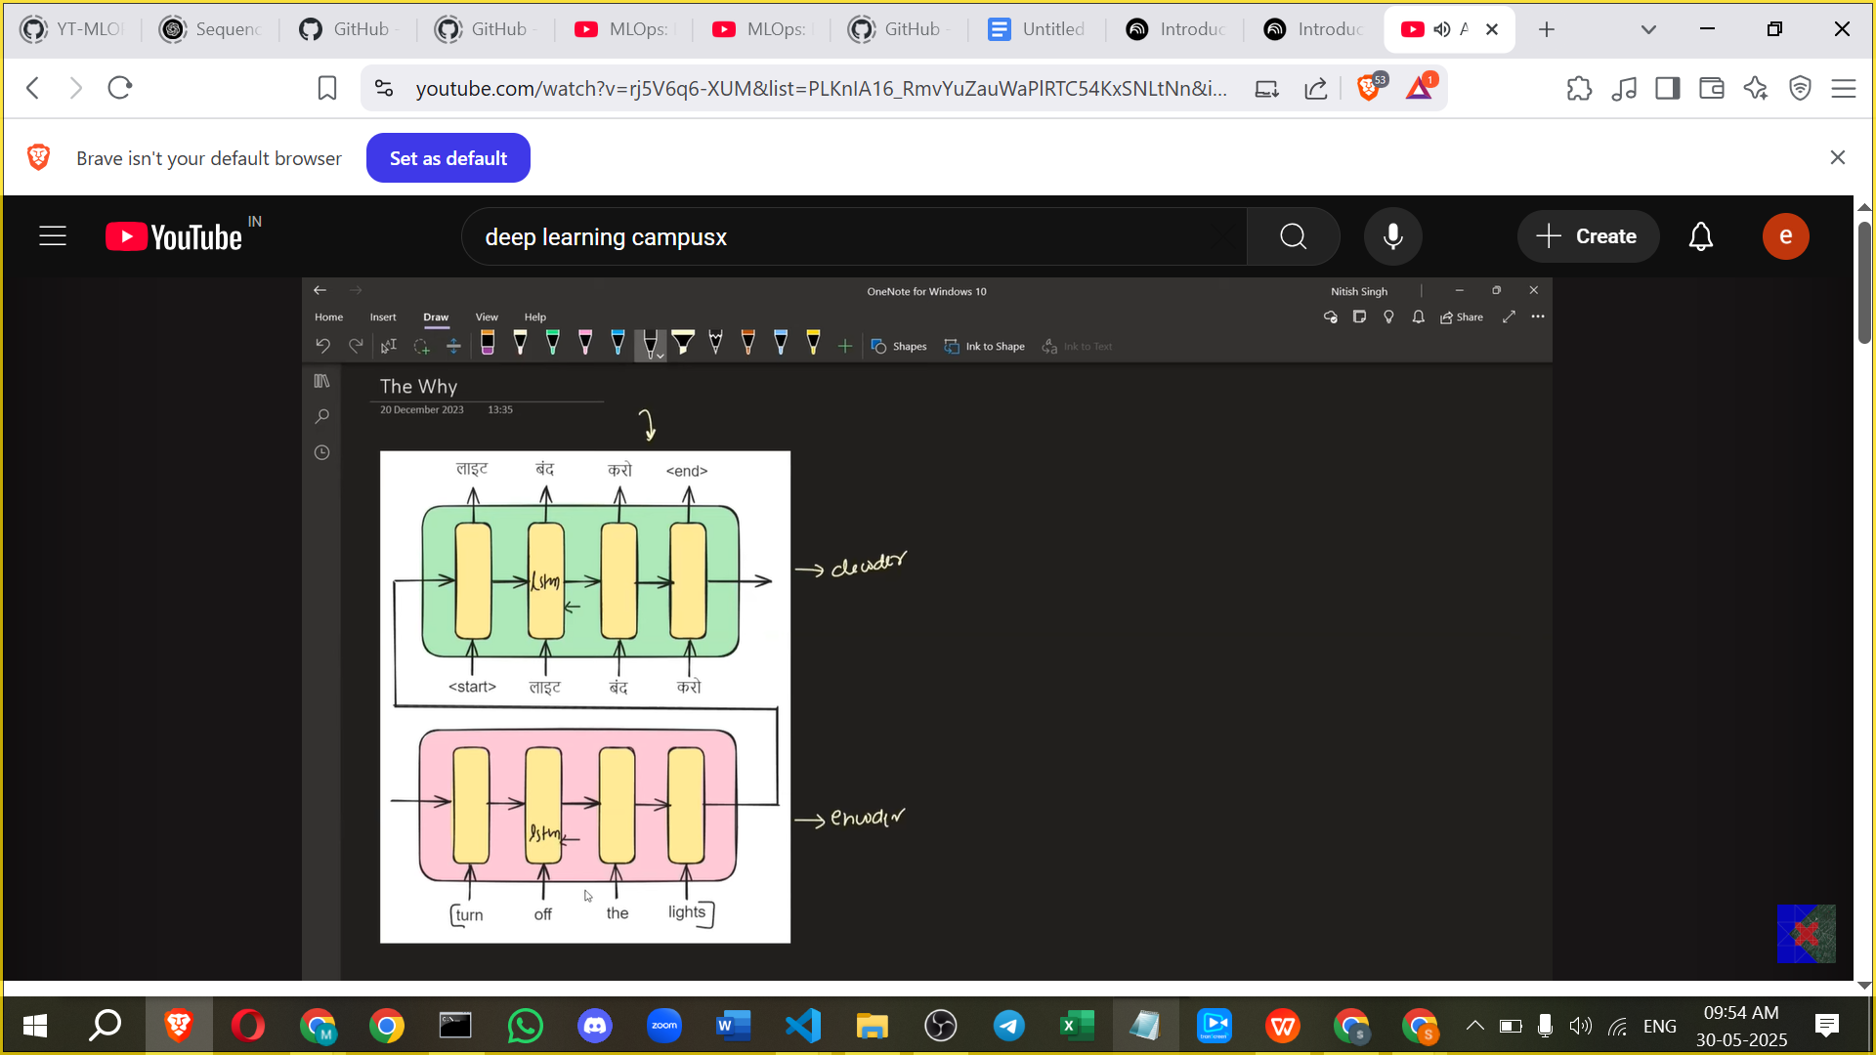**
   * **Problem 1 (Encoder Side):** The Encoder is forced to process and remember the entire input sentence to generate a single summary vector.

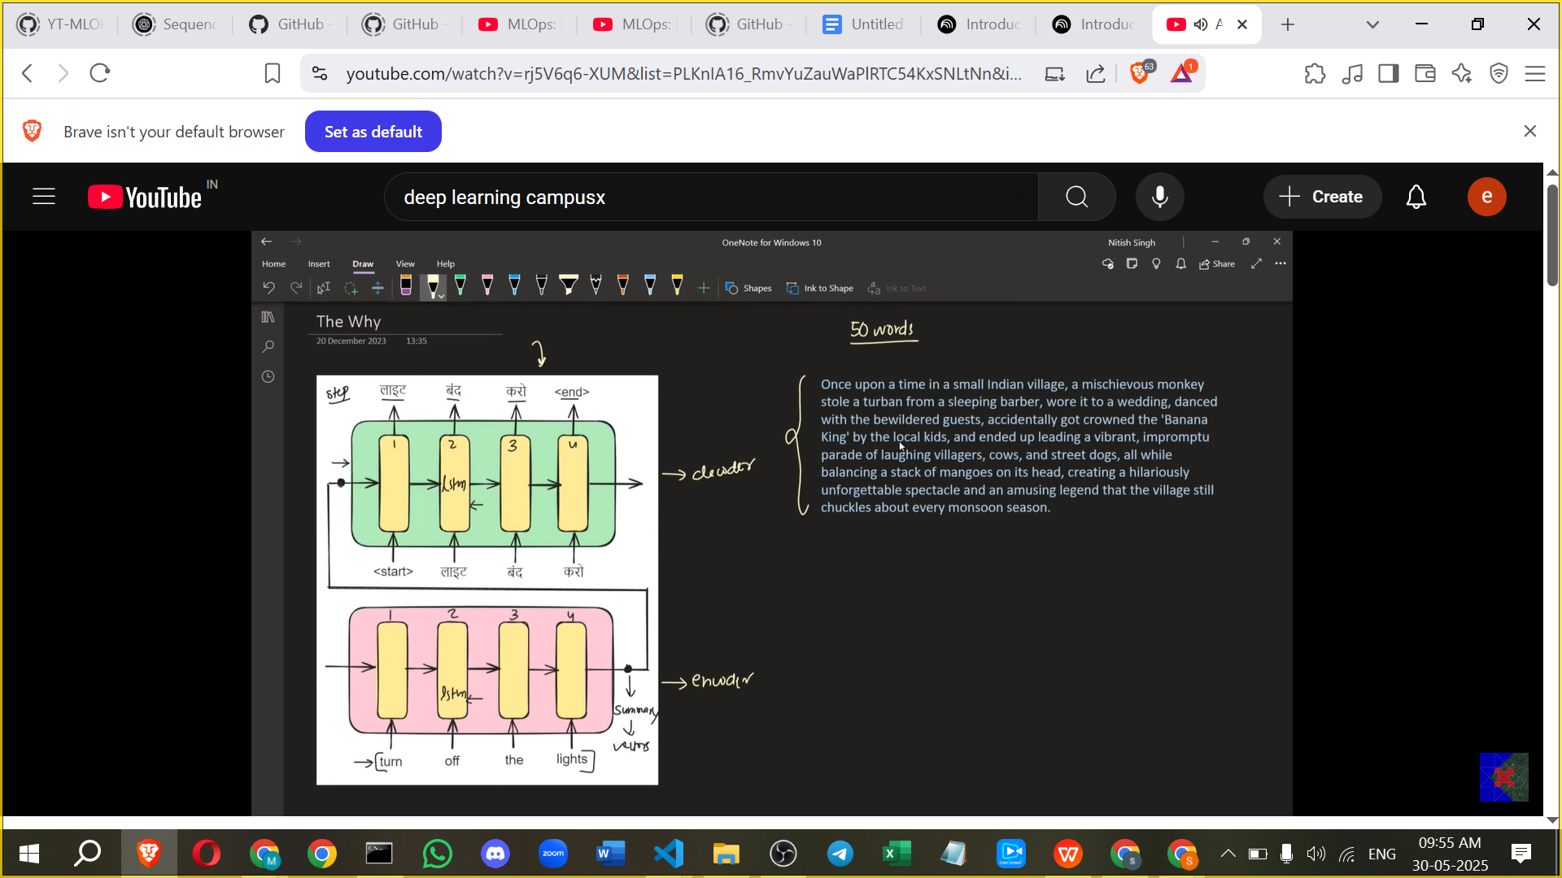

* + - This is particularly challenging for **long sentences** (e.g., greater than 25-30 words).
    - Just like humans find it difficult to read a long sentence once, close their eyes, and translate the whole thing, the Encoder struggles to compress all the information into one fixed-size vector.
    - This puts **too much pressure** on the Encoder.

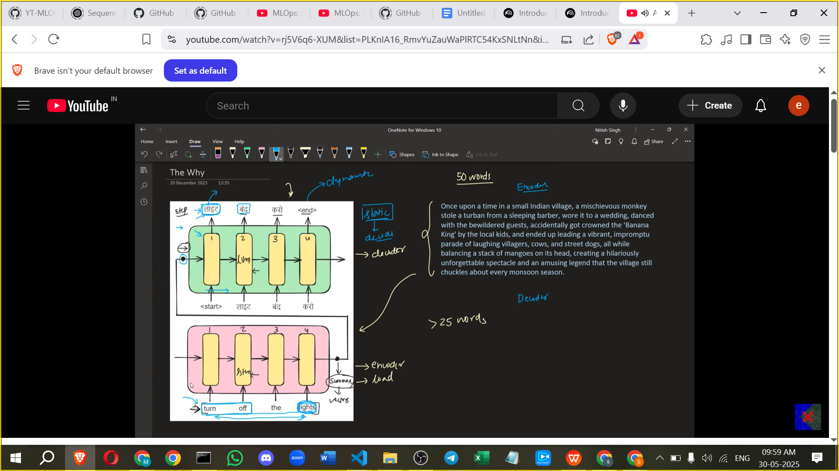

* + **Problem 2 (Decoder Side):** The Decoder receives the **same static summary vector** at every time step for generating each output word.
    - However, to translate a specific output word (e.g., "लाइट" from "Turn off the lights"), the Decoder doesn't need the entire input sentence; it only needs the specific relevant input word(s) (e.g., "lights").
    - The static representation makes it difficult for the Decoder to figure out which part of the input sentence is relevant for the current output word.
    - It would be better if the Decoder could dynamically focus on the particular section of the input sentence it needs at that moment.

1. **Attention Mechanism: The Solution**

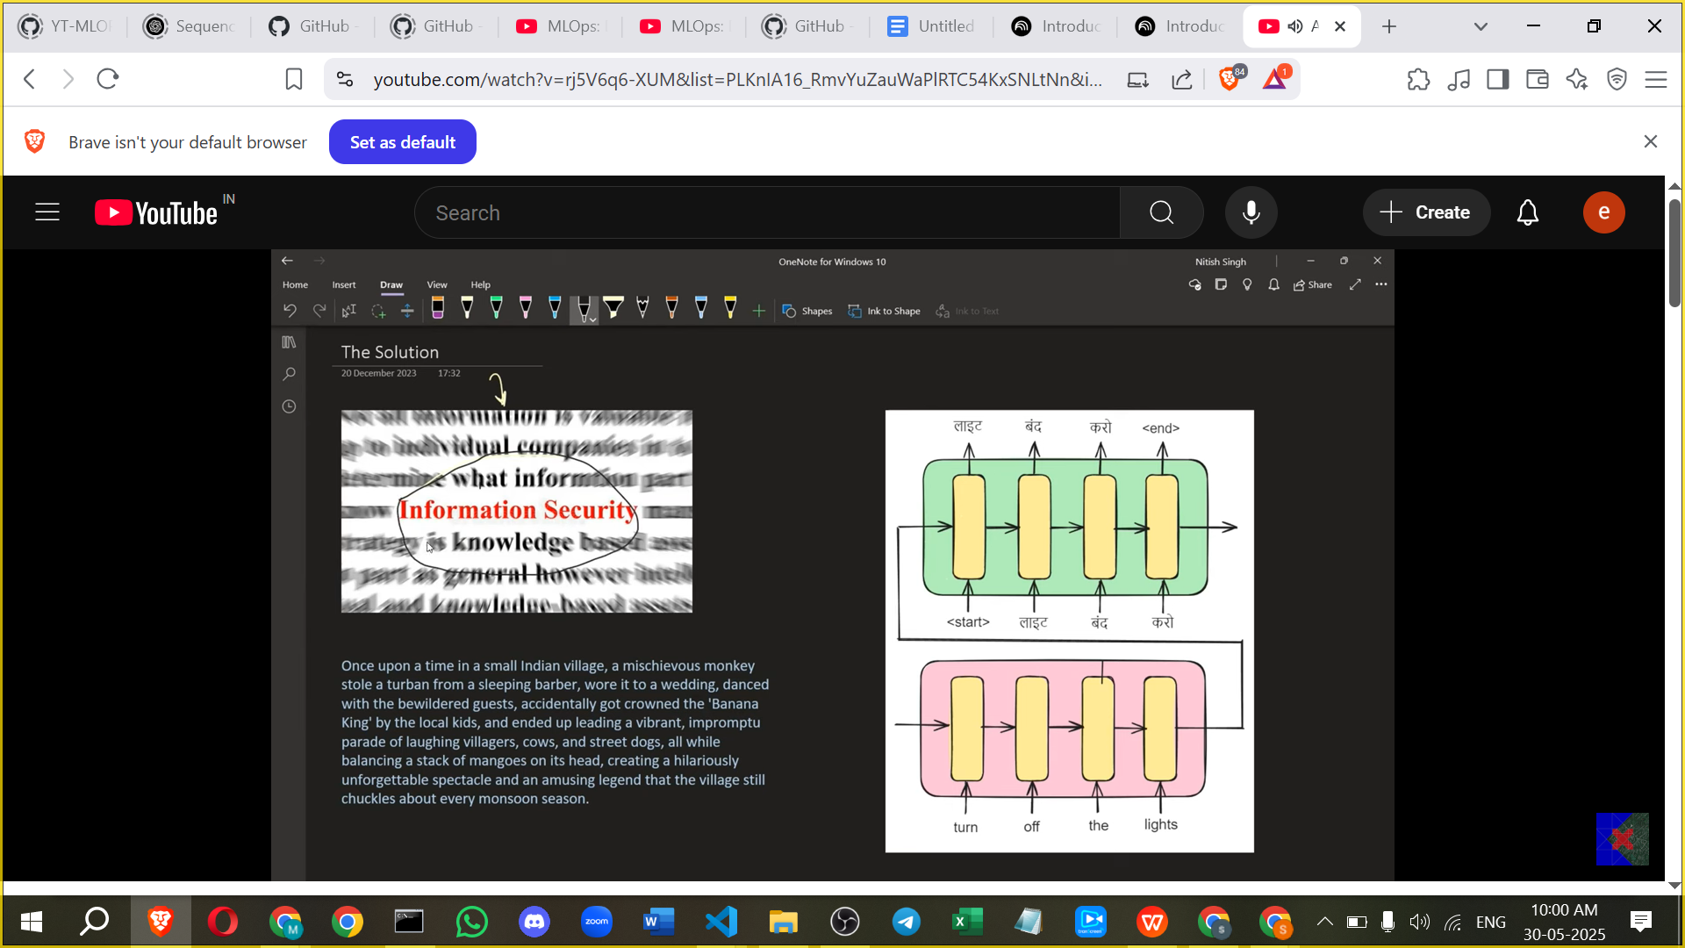

* + The solution mimics how humans translate long texts: we don't memorise everything at once but focus on parts as we go. We create an "attention span" or "attention region" where our focus is.
  + The **Attention Mechanism** introduces this concept into the architecture.
  + At each step of the Decoder, the system **dynamically generates information** about which parts of the Encoder's processing (which time steps or which hidden states) are most important for generating the current output word.

1. **Architecture with Attention**

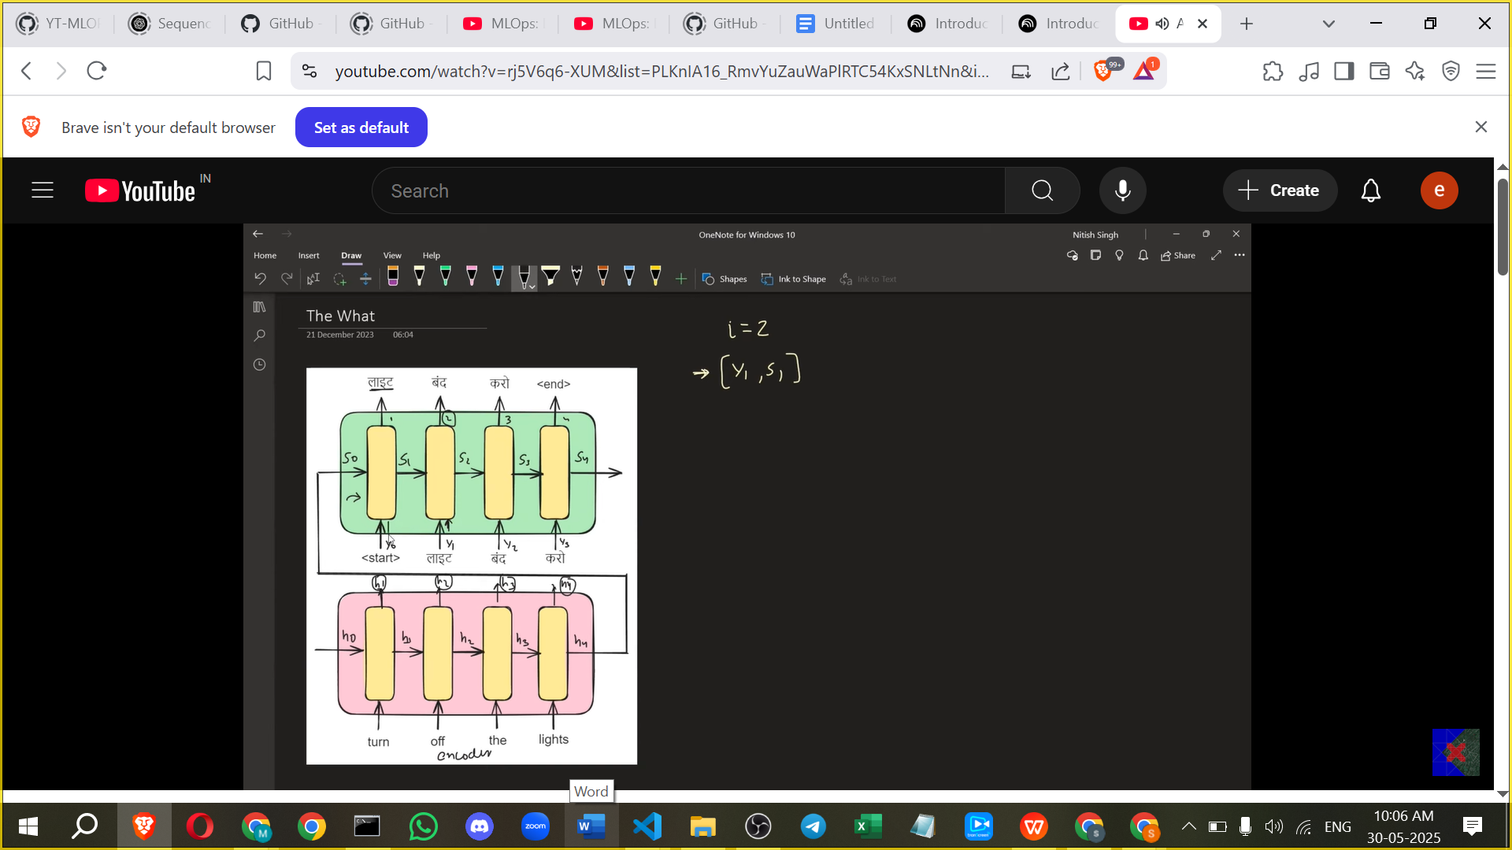

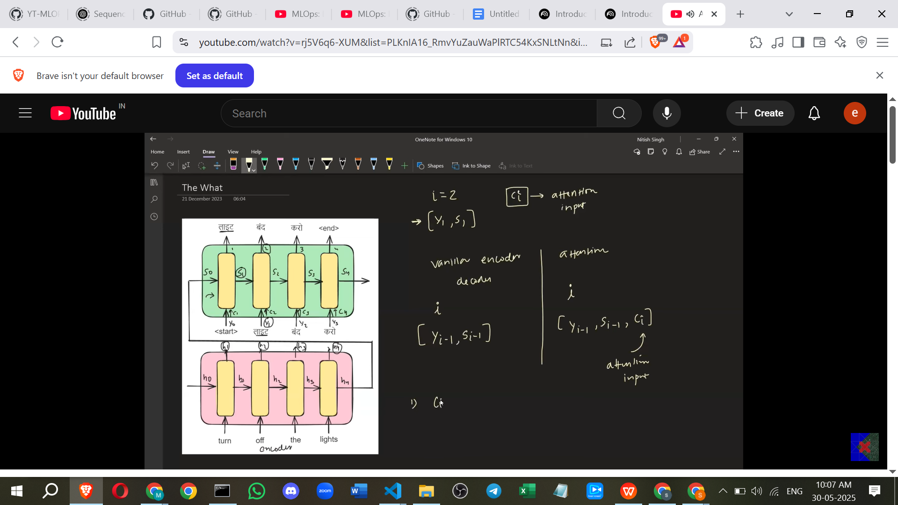

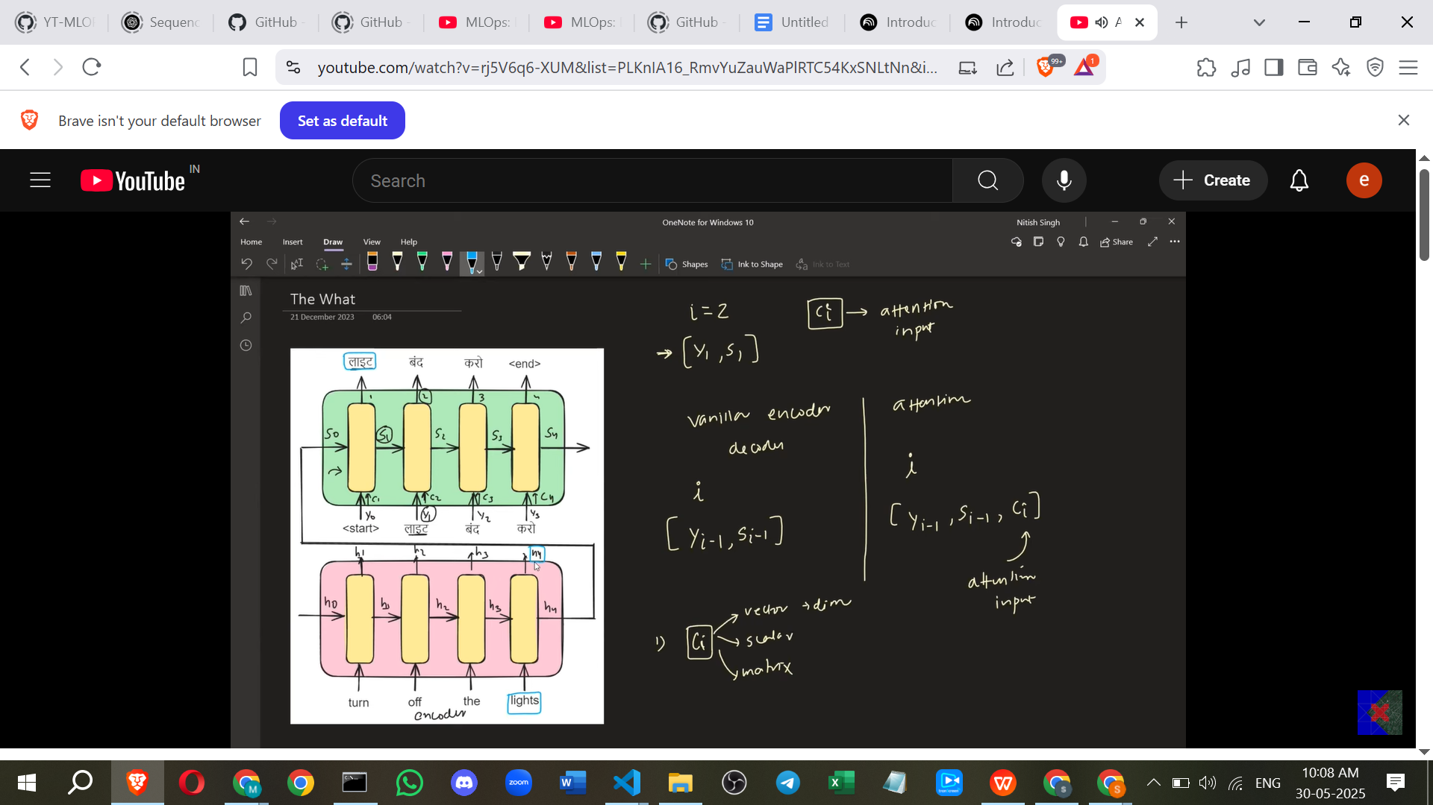

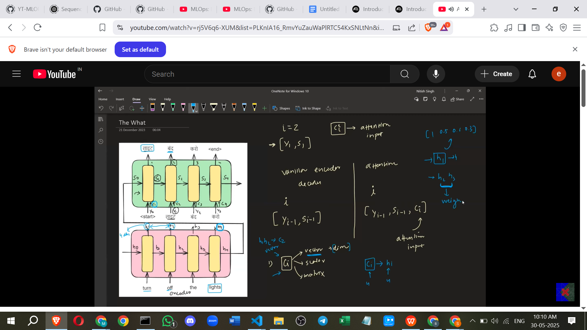

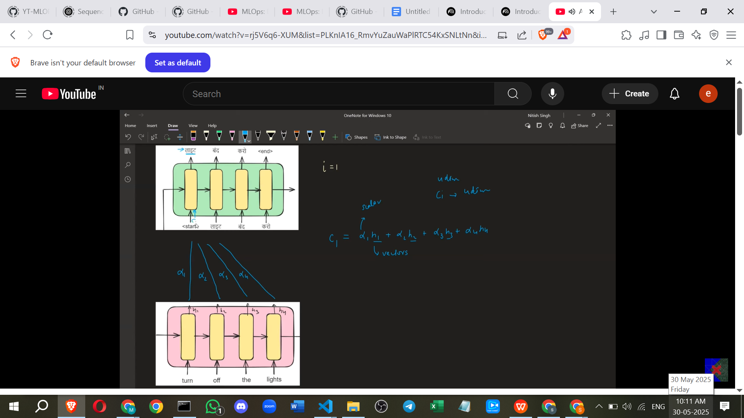

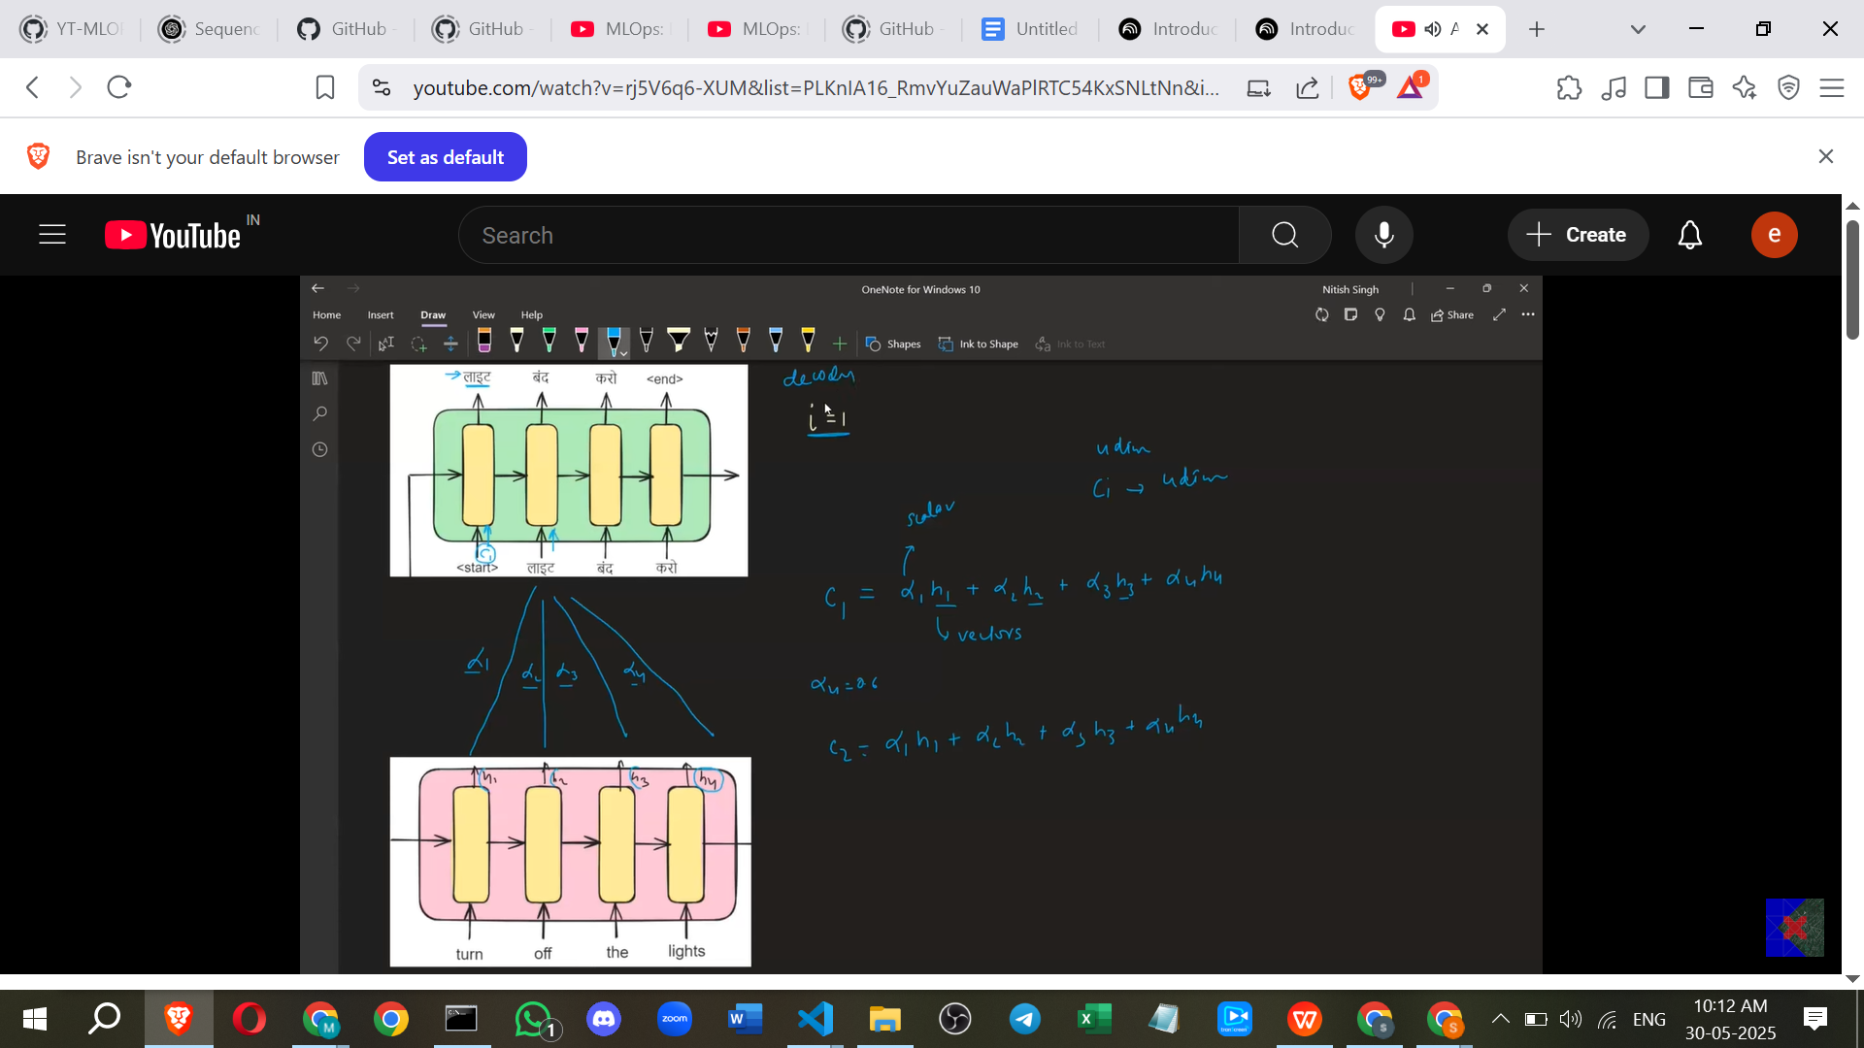

* + In the standard Encoder-Decoder, the Decoder at time step i typically takes two inputs: the previous output word (y_i-1) and the previous Decoder hidden state (s_i-1).
  + In an **Attention-Based Encoder-Decoder**, the Decoder at time step i takes **three inputs**: y_i-1, s_i-1, and a new input called the **Attention Input (c_i)**.

1. 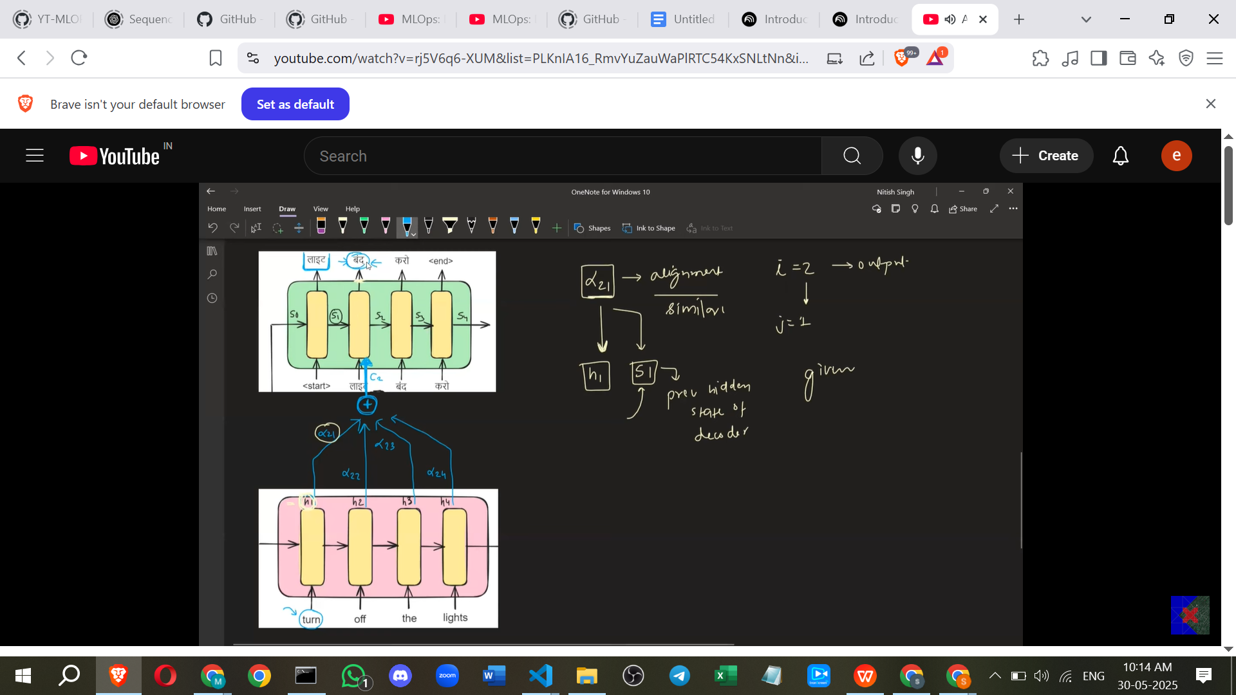
   * This c_i is the vector that provides the "attention" or dynamic context information for time step i.
   * c_i is a **vector** and has the **same dimension** as the Encoder's hidden states (h_j).
   * The c_i vector is calculated as a **weighted sum** of all the Encoder's hidden states (h_j).
     + The formula is c_i = Σ_j (α_ij * h_j).
     + Here, h_j represents the hidden state of the Encoder at time step j.
     + α_ij represents the **attention weight** (a scalar) assigned to the Encoder's hidden state h_j when generating the output at Decoder time step i.
     + These α_ij values are also called **alignment scores** or similarity scores. They indicate how much the Encoder's j-th hidden state is relevant to the Decoder's i-th output.
2. **Calculating the Attention Weights (α_ij)**
   * The core challenge is determining these weights α_ij.
   * An attention weight α_ij (e.g., α_21 which tells how much Encoder step 1 (h1) matters for Decoder step 2) depends on two things:
     + The Encoder's hidden state at step j (h_j).
     + The Decoder's **previous** hidden state at step i-1 (s_i-1). The previous decoder state is important because it captures the context of the translation done so far.
   * So, α_ij is a function of h_j and s_i-1: α_ij = f(h_j, s_i-1).
   * Instead of trying to find a fixed mathematical function f, a **Neural Network (NN)** is used to learn this function.

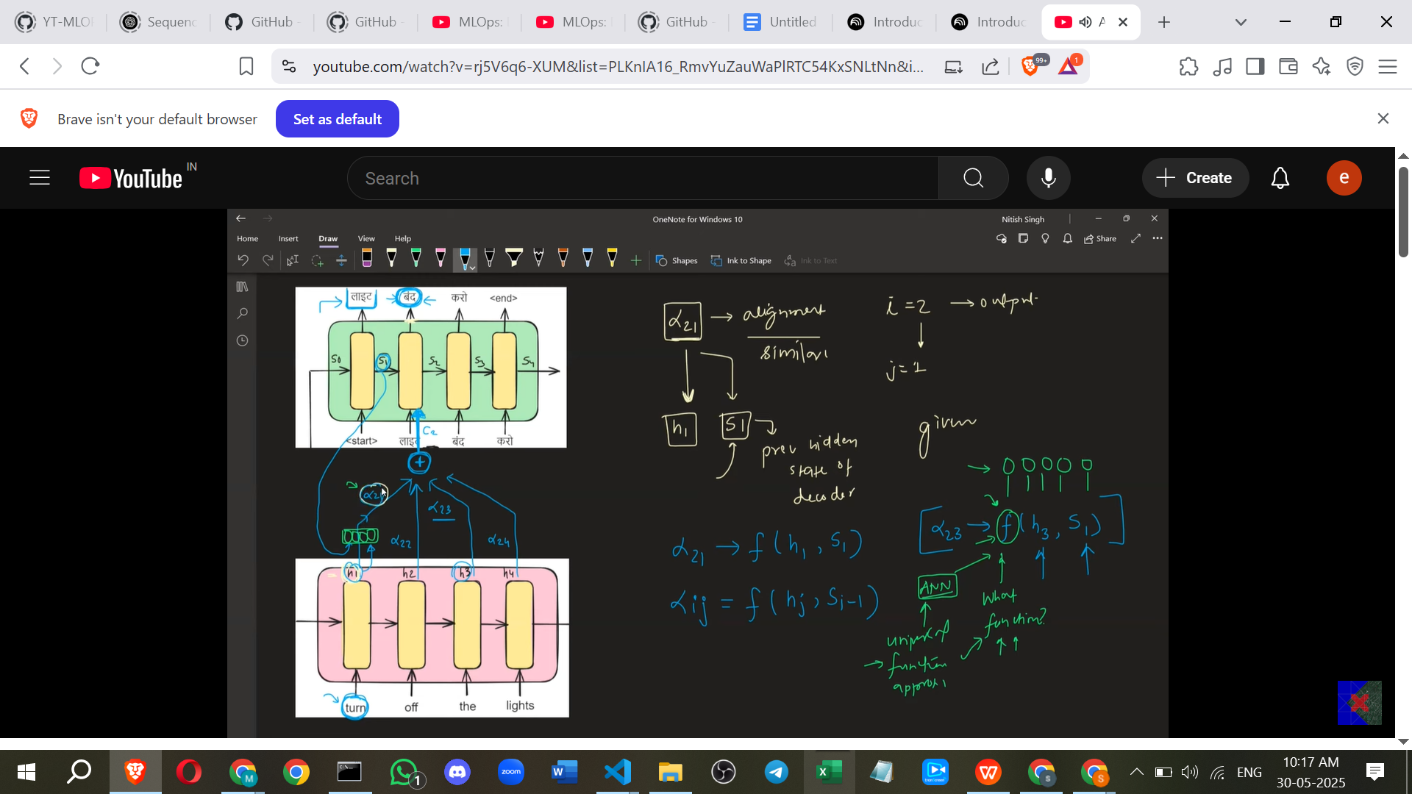

* + This NN takes h_j and s_i-1 as inputs and outputs a score related to α_ij.
  + This small NN is trained **end-to-end** along with the rest of the Encoder-Decoder network using techniques like backpropagation through time. This allows the network to automatically learn which input states are relevant for which output states.

1. **Working Example (Calculation of c_2 for "बंद"):**

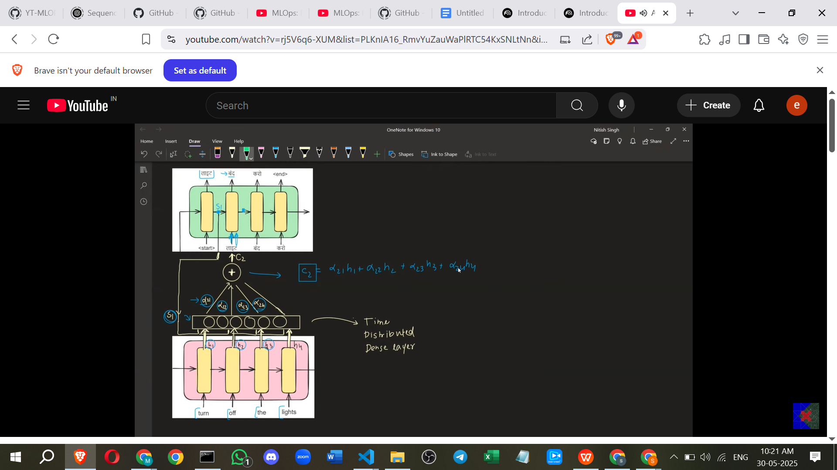

* + Suppose the Decoder is at time step 2, about to print "बंद" (from "Turn off the lights" -> "लाइट बंद करो").
  + To calculate the attention input c_2, we need the attention weights (α_2j) for all Encoder hidden states (h_j) and the weighted sum: c_2 = α_21*h_1 + α_22*h_2 + α_23*h_3 + α_24*h_4.
  + To get these weights, the NN is used. For example, to get α_21, the NN takes the Decoder's *previous* hidden state (s_1, after printing "लाइट") and the Encoder's hidden state for "Turn" (h_1) as input.
  + Similarly, α_22 is calculated using s_1 and h_2 (for "off"), α_23 using s_1 and h_3 (for "the"), and α_24 using s_1 and h_4 (for "lights").
  + Once all α_2j are calculated, they are used to compute the weighted sum c_2.
  + This c_2 is then passed to the Decoder at step 2, along with y_1 (the previous output "लाइट") and s_1 (the previous decoder state) to help predict "बंद" and calculate the next state s_2.

1. **Empirical Evidence of Effectiveness**
   * Research papers show that Attention-based models perform better than standard Encoder-Decoders, especially for long sentences.
   * A graph comparing models shows that the **BLEU score** (a translation quality metric) for Attention-based models remains higher and more stable as sentence length increases beyond 30 words, unlike other models where the score drops significantly.

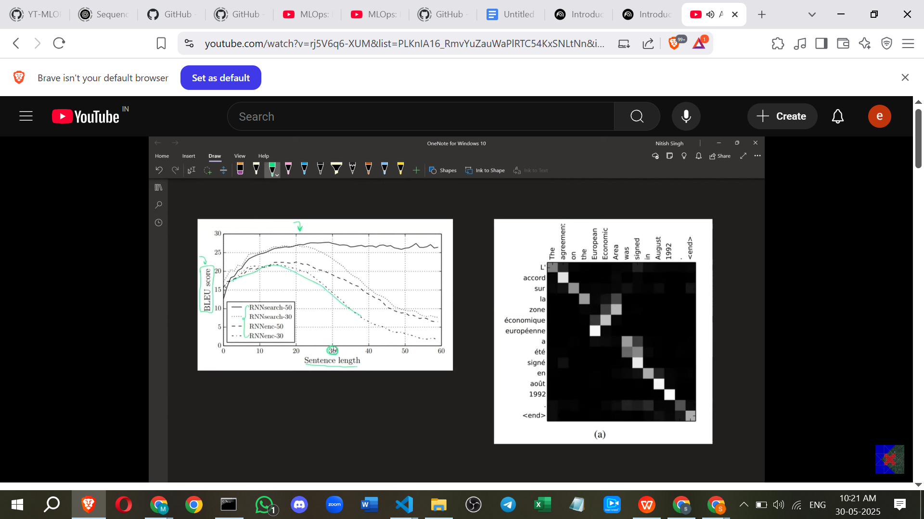

* + **Attention plots** (visualisations of the α_ij weights) show the mechanism aligns relevant words. For instance, when translating "European agreement" to French, the attention weights show that the French translation for "European" attends most strongly to the English word "European", and the translation for "agreement" attends most strongly to "agreement". This visually confirms that the model is learning to focus on the right input words.

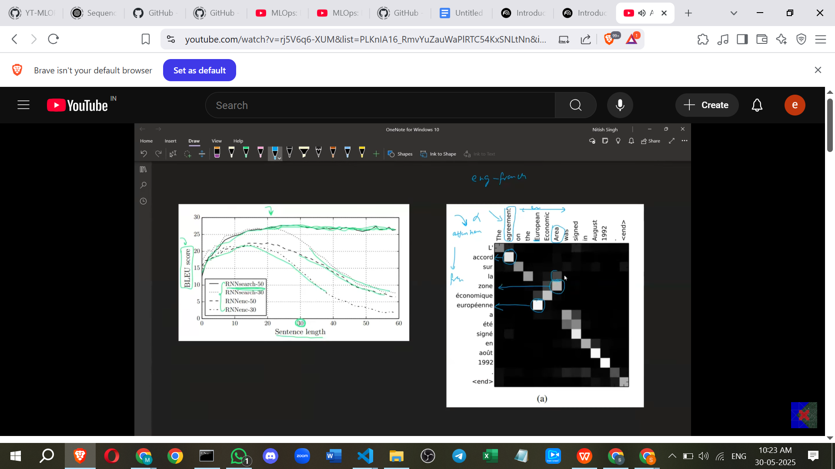

1. **Implementation Detail from Original Paper**
   * The original paper on Attention used **Bi-directional LSTMs** in the **Encoder** (but not the Decoder).

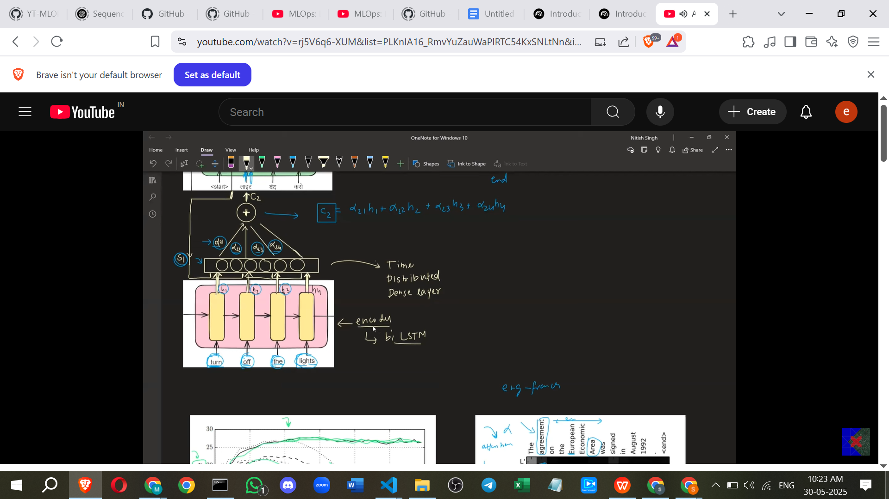

* + **Bi-directional LSTMs** process the input sequence in both forward and backward directions, giving the Encoder hidden states (h_j) context from both preceding and succeeding words.
  + This architectural choice in the Encoder can improve translation quality, while the Attention mechanism itself works the same way using these enriched hidden states.

**Additional Points to Aid Learning (From My Side - Not Directly From Sources)**

Here are some extra points to deepen your understanding of the Attention Mechanism:

* **Core Concept: Dynamic Context:** Think of the standard Encoder-Decoder providing a *single summary* of the input, like giving someone a brief abstract and asking them to write a full report based only on that abstract, referring back to it constantly. Attention is like giving them the abstract *plus* the ability to quickly flip back to the *most relevant pages* of the original document whenever they need to write a specific sentence in the report. The attention input c_i is that dynamic context vector, specifically computed for *each* output step i.
* **Contrast with Static Context:** The main bottleneck in the standard architecture is squeezing all input information into a single, fixed-size "context vector" (the Encoder's final hidden state or the summary vector). For long sequences, this single vector simply cannot hold enough information, leading to performance degradation. Attention bypasses this bottleneck by creating a *new context vector* (c_i) at *each* Decoder step, which is specifically tailored to what is needed to produce the *current* output word.
* **Why s_i-1 is Important:** The previous Decoder hidden state s_i-1 holds information about the words the Decoder has *already* generated. When deciding where to focus attention in the input (h_j) to generate the *next* word, knowing what has already been translated is crucial. For example, if you've just translated "Turn off the", you know you need to focus on the input word "lights" next to complete the phrase "Turn off the lights". The s_i-1 helps the Attention NN understand the current state of the translation process.
* **The Neural Network f:** This NN learns the *relationship* between the input and output sequence elements. By training it end-to-end, the model automatically discovers which pairs of (h_j, s_i-1) should result in a high alignment score (α_ij). For translation, it learns to align words that correspond to each other (like "lights" and "लाइट", or "agreement" and "accord").
* **Beyond Translation:** Attention is not just for machine translation. It's a fundamental concept used in many sequence-to-sequence tasks where the output sequence needs to selectively attend to different parts of the input sequence. Examples include:
  + **Text Summarization:** The model needs to attend to important sentences or phrases in the source document when generating parts of the summary.
  + **Speech Recognition:** When outputting a word, the model needs to attend to the relevant segment of the audio input.
  + **Image Captioning:** When generating a word in the caption, the model needs to attend to the relevant region(s) of the image.
* **Interpretability:** A great benefit of the Attention Mechanism is that the attention weights (α_ij) provide a degree of interpretability. By visualising the attention matrix (like the plot shown in the source), you can see *what* the model was looking at in the input when it produced a specific output. This helps understand *why* the model made a certain prediction.

In summary, the **Attention Mechanism** is a powerful technique that allows neural networks, particularly in sequence-to-sequence tasks, to **dynamically focus** on the most relevant parts of the input sequence when producing an output sequence, thereby overcoming the limitations of fixed-size context vectors, especially for long sequences. This dynamic focusing is achieved by learning **attention weights** that determine the importance of each input element for generating each output element, often facilitated by a small neural network.

======================================================================